**Locating Web Page Elements:**

package com.ecommerce.test;

import org.openqa.selenium.*;

import org.openqa.selenium.chrome.ChromeDriver;

import org.openqa.selenium.firefox.FirefoxDriver;

import org.openqa.selenium.ie.InternetExplorerDriver;

public class LocatingElementsDemo {

public static void main(String[] args) throws InterruptedException {

WebDriver driver = new ChromeDriver(); // new FirefoxDriver();

StringbaseUrl="https://accounts.google.com/signup/v2?biz=true&flowEntry=SignUp";

driver.get(baseUrl);

// Let's locate the first name text field by its id.

WebElement firstNameTF = driver.findElement(By.id("firstName"));

System.out.println("firstNameTF details " + firstNameTF);

firstNameTF.sendKeys("My First Name is ");

// Let's locate the surname name text field by its name.

WebElement surNameTF = driver.findElement(By.name("lastName"));

surNameTF.sendKeys("My Surname is ...");

// The Next button using its class

WebElement nextButton = driver.findElement(By.className("VfPpkd-vQzf8d"));

System.out.println("Text on the button is "+nextButton.getText());

//close the browser and quit.

//driver.close();

}}

**Output Screenshots:**

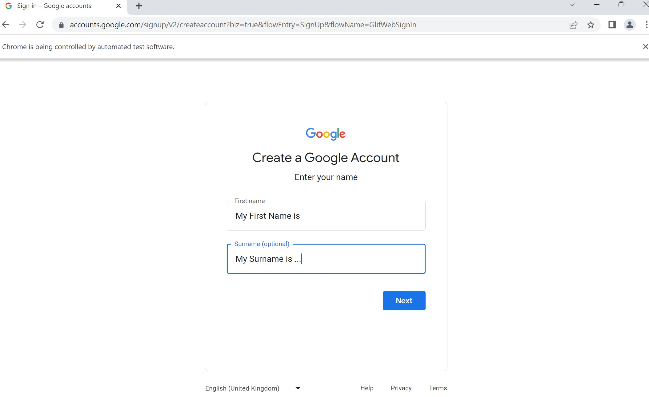

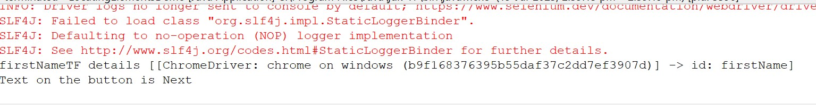

**// Using CSS:**

package com.ecommerce.test;

import org.openqa.selenium.*;

import org.openqa.selenium.chrome.ChromeDriver;

import org.openqa.selenium.firefox.FirefoxDriver;

import org.openqa.selenium.ie.InternetExplorerDriver;

import org.openqa.selenium.support.ui.Select;

public class LocatingElementsDemo {

public static void main(String[] args) throws InterruptedException {

WebDriver driver = new ChromeDriver(); // new FirefoxDriver();

facebookAccCreation(driver);

}

static void facebookAccCreation(WebDriver driver) {

String baseUrl = "https://www.facebook.com/r.php?locale=en_GB&display=page";

driver.get(baseUrl);

String cssDay = "#day";

WebElement cssDaySelect = driver.findElement(By.cssSelector(cssDay));

Select daySelect = new Select(cssDaySelect);

daySelect.selectByVisibleText("11");

}

}

**Screenshot:**

